State-Adopted Curricula ELA HQIM Reports: K-2 Final Reports
The reports produced from the state’s review process contain information districts and teachers can use to:
- determine if they are using HQIM in their classrooms, and
- better understand the strengths, weaknesses, and opportunities within their materials to support strong implementation that benefit students.
Gateway 1 indicators ensure high-quality texts are the central focus of lessons, are at the appropriate grade level text complexity, and are accompanied by quality tasks aligned to the college and career-ready standards of reading, writing, speaking, listening, and language in service to grow literacy skills. | Gateway 2 indicators focus on the ways in which materials build knowledge through integrated reading, writing, speaking, listening, and language. | Gateway 3 indicators examine the ways in which materials support teachers to fully utilize the curriculum, understand the skills and learning of their students, and support a range of learners.
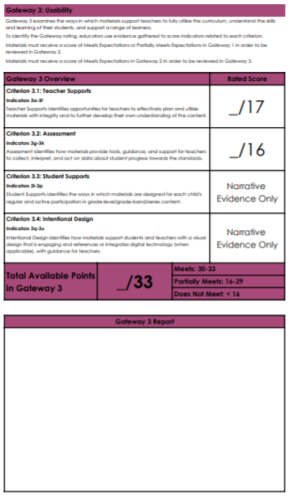

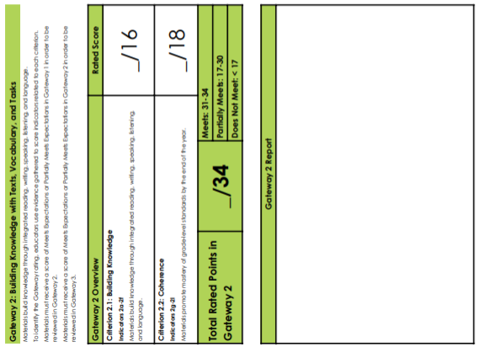
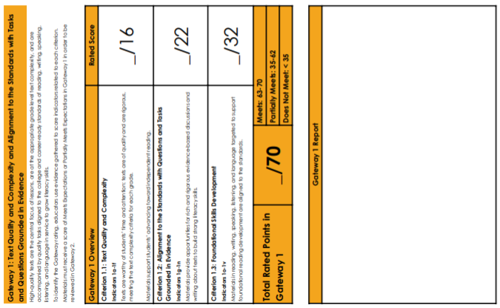

The final reports include an overall rating as well as information highlighting the program’s overall strengths and weaknesses found by review teams. Scores from the rubrics can result in one of three outcomes – Meets (Green), Partially Meets (Yellow), and Does Not Meet (Red). These designations help educators determine the strength and quality of the materials that were reviewed.

Final Reports
Into Reading

MyView Literacy

Our EL Language Arts

Wit & Wisdom w/ Fundations

Wonders

