**HQIM SESSION 1**

Elements 1 and 2 Case Study

At the end of the 22-23 school year, **School District A** made the decision to adopt high-quality instructional materials for the following year. The decision was made by the district leadership team (the Superintendent and the Director of Curriculum) and the high school principal following several years of a decline in student achievement on the state standardized assessment. During the pandemic, results plummeted even more. Teachers said that they did not have access to resources that could be used flexibly online, in-person, and to support students who were experiencing learning loss. The district leadership team decided to act fast and adopted SAVVAS products for both K-12 Math and ELA. They were excited for their teachers to feel supported with brand new resources for both ELA and Math. The SAVVAS products were determined to be considered high-quality instructional materials, appearing on Mississippi Department of Education’s approved list. This decision was communicated to all principals and teachers over the summer, and the superintendent worked diligently with the publisher to procure all the needed materials for both subjects prior to the start of school. Materials were shipped to buildings two weeks prior to the first day. Teachers reported gratitude about the new materials and the Superintendent and Director of Curriculum planned to walk through each building to monitor implementation of the new HQIM at the end of September.

Math and ELA HQIM were bought for the entire district: two elementary schools, two middle schools, and one high school in the district.

In the Fall, the Superintendent and the Director of Curriculum visited each of the five schools in the district. They found:

* One elementary school was using resources from SAVVAS My View in 50% of the classrooms observed. The other elementary school had not unpacked the My View boxes yet. Neither elementary school had “tackled” implementing SAVVAS Envision yet because it was just too much for their teachers in year 1 to roll out two new programs.
* In the middle schools, the HQIM was unboxed, and the leaders saw evidence that both My Perspectives and EnVision were being used in classrooms. However, teachers reported being uncomfortable with how many resources were available within the HQIM. They said that it was sometimes easier to defer back to the “simpler” worksheets that they had been using prior to adoption.
* In high school, all teachers were using the HQIM in both math and ELA. The principal scheduled professional development prior to the first day of school so that teachers had a baseline understanding of the various components of each HQIM. She reported that priorities were set across content areas for the roll out based on content visions that teachers had co-created with the school leadership team. The principal said that the teachers could pick and choose which parts of the HQIM to implement but most decided to just use it as designed.

# **Reflection Questions: Case Study 1**

1. What did this district prioritize in their launch of HQIM?
2. What steps would have led to a more successful quarter one walk through?
3. Pretend you are the superintendent reflecting on the 8 Elements Tool after the walk through. How would you rate your district based on the case study above? Use evidence to justify your ratings.

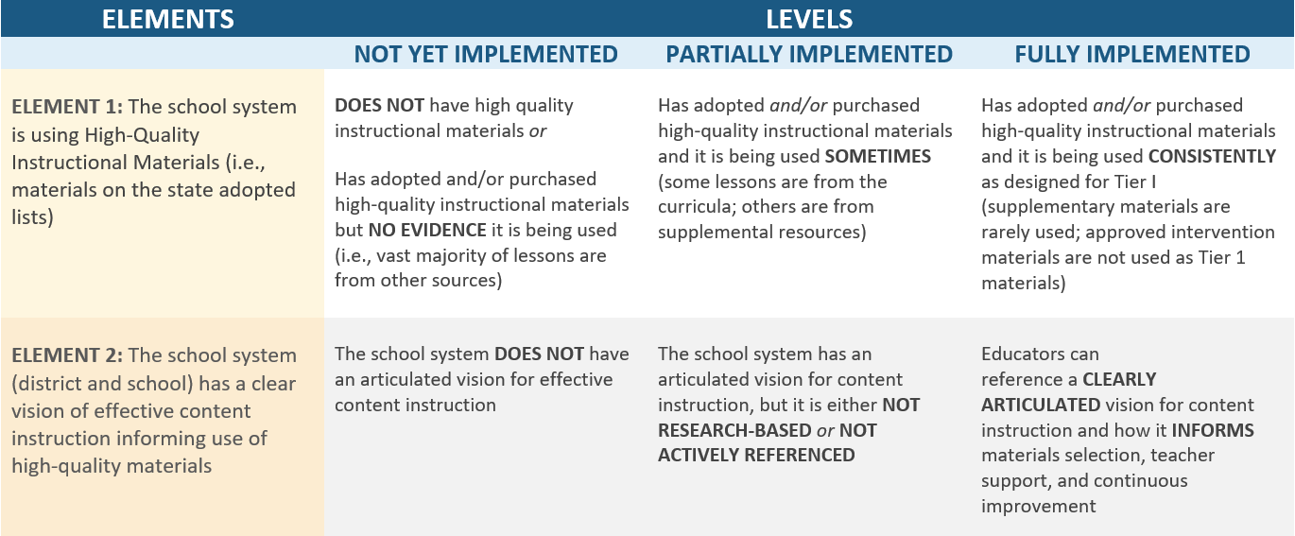

# **Reflection Questions: Case Study 2**

Pretend you are supporting or coaching this district (as a state leader, regional service provider, etc.) What are the two next steps you would recommend to the superintendent to  improve the roll out and implementation of HQIM for ELA and Math in District A?

First Step:

Second Step: