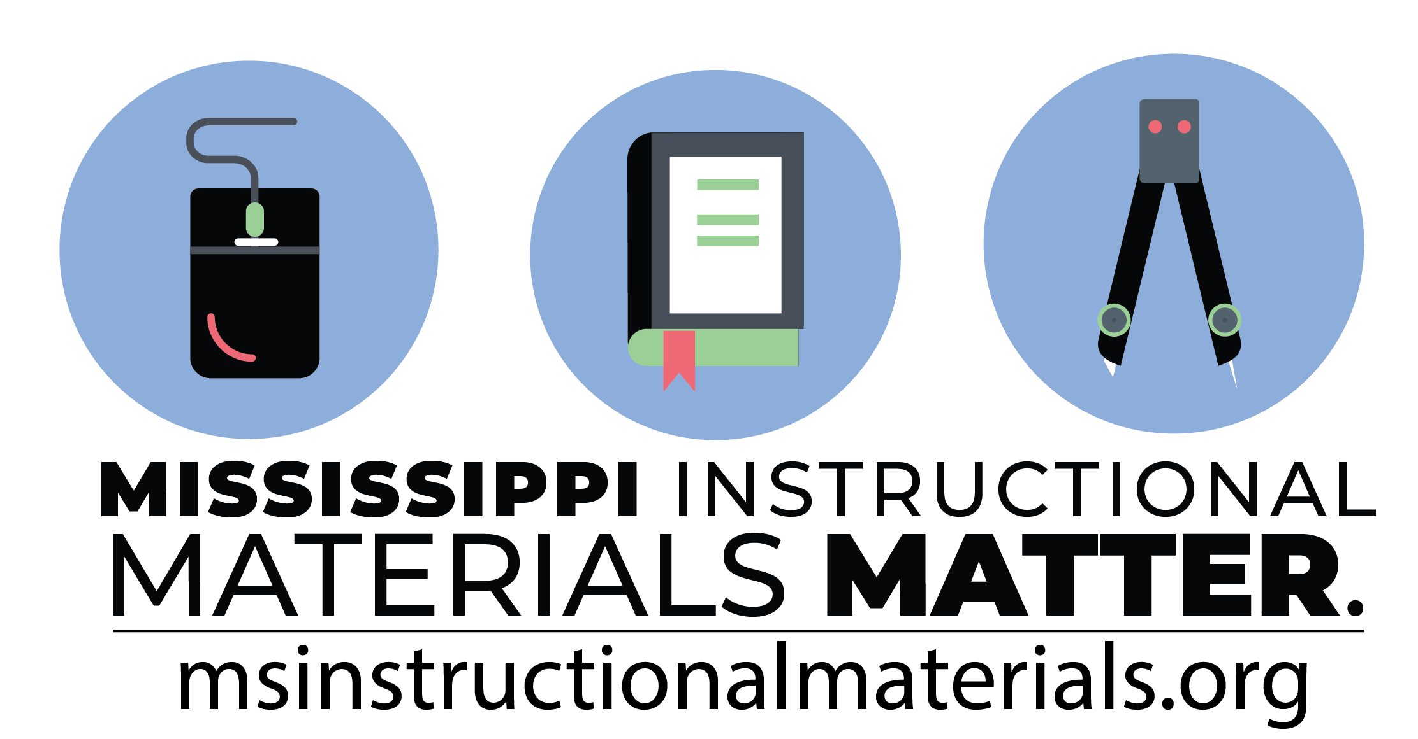**EDUCATOR PREP**

TEXTBOOK ADOPTION REPORT

OFFICE OF INSTRUCTIONAL MATERIALS & LIBRARY MEDIA

­

Secondary CTE programs in Mississippi face many challenges resulting from sweeping educational reforms at the national and state levels. Schools and teachers are increasingly being held accountable for providing applied learning activities to every student in the classroom. This accountability is measured through increased requirements for mastery and attainment of competency as documented through both formative and summative assessments. This document provides information, tools, and solutions that will aid students, teachers, and schools in creating and implementing applied, interactive, and innovative lessons. Through best practices, alignment with national standards and certifications, community partnerships, and a hands-on, student-centered concept, educators will be able to truly engage students in meaningful and collaborative learning opportunities.

**Educator preparation** is a program for students in the education and training career cluster. It is a high school program with courses designed to attract students to the field of education, provide information and field experiences relevant to pursuing a degree in education, and prepare students for the rigors of a career in education in hopes they will remain long-term educators. The educator preparation program includes classroom and hands-on experiences that will prepare students for employment or postsecondary education. Students will develop a professional portfolio featuring work samples, experiences, and career plans related to the field.

**OVERALL RATING:** MEETS EXPECTATIONS

|  |  |
| --- | --- |
| **CEV MULTIMEDIA** SNAPSHOT | |
| **Program Strengths**   * No strengths were provided. | **Program Challenges**   * Not all topics in the curriculum are included in the lessons. |

# CEV MULTIMEDIA REVIEW

|  |  |
| --- | --- |
| **RUBRIC** | Findings |
| **GATEWAY 1 | CRITERION 1.1: Alignment and Coherence** Materials adequately address the National Standards for Business Education. | **13.1 points out of 16 points** |
| **GATEWAY 2 | CRITERION 2.1: Student Learning** Materials identify ways in which materials are designed for each student’s regular and active participation in grade-level/grade band/series content. | **14 points out of 16 points** |
| **GATEWAY 3 | CRITERION 3.1: Teacher Supports** Materials support teacher planning, learning, and understanding of the Standards. Materials provide teachers with guidance to build their own knowledge and to give all students extensive opportunities and support to explore key concepts  **GATEWAY 3 | CRITERION 3.2: Assessment** Materials offer assessment opportunities that genuinely measure progress and elicit direct, observable evidence of the degree to which students can independently demonstrate the assessed standards.  **GATEWAY 3 | CRITERION 3.3: Technology** Materials support effective use of technology to enhance student learning. Digital materials are accessible and available in multiple platforms. | **20.6 points out of 24 points** |

# TOTAL SCORE: 47.7 POINTS OUT OF 56 POINTS